Project Design Phase-II
Data Flow Diagram & User Stories
Date | 01 October 2026
Team ID | 6ab6292ddcdae33acb3906da
Project Name | Import Data Using Transform Maps
Maximum Marks | 4 Marks
Data Flow Diagrams:
A Data Flow Diagram (DFD) is a visual representation of the information flows within a system. For this project it shows how employee training data moves from a spreadsheet into ServiceNow through an Import Set and a Transform Map, how the employee department is pulled in by dot-walking, and how roles and Access Control Lists (ACLs) control who can see the data.
Level 0 (context diagram)
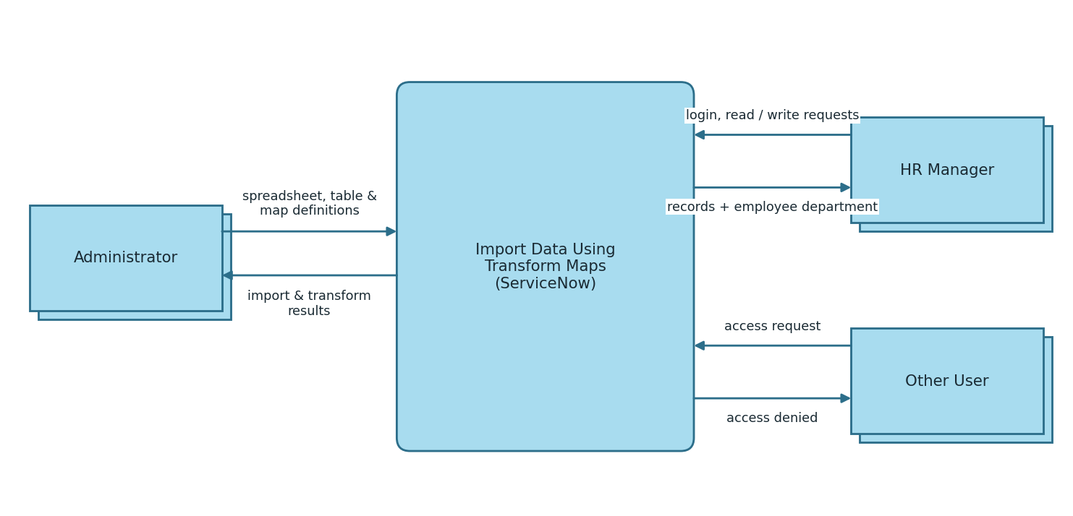
Figure 1: DFD Level 0

Level 1: Importing data using a transform map
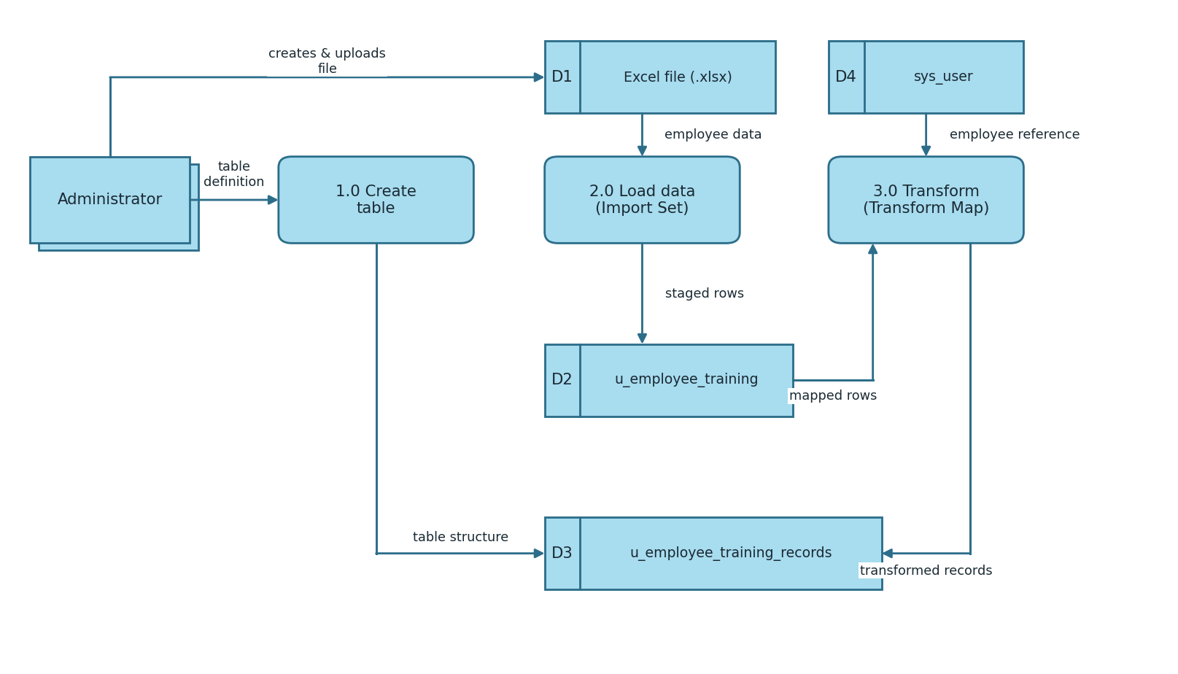
Figure 2: DFD Level 1 (import pipeline)
Flow
- Administrator creates the Employee Training Records table (1.0) with Training Name, Completion Date, Status and Employee fields.
- Administrator prepares the .xlsx file (D1) and uploads it using Load Data (2.0); the rows are staged in the import set table u_employee_training (D2).
- Administrator creates the transform map and field maps; the sys_user table (D4) is used to resolve the Employee reference.
- Running the transform (3.0) moves the mapped rows into u_employee_training_records (D3).

Level 1: Dot-walking and securing data with ACLs
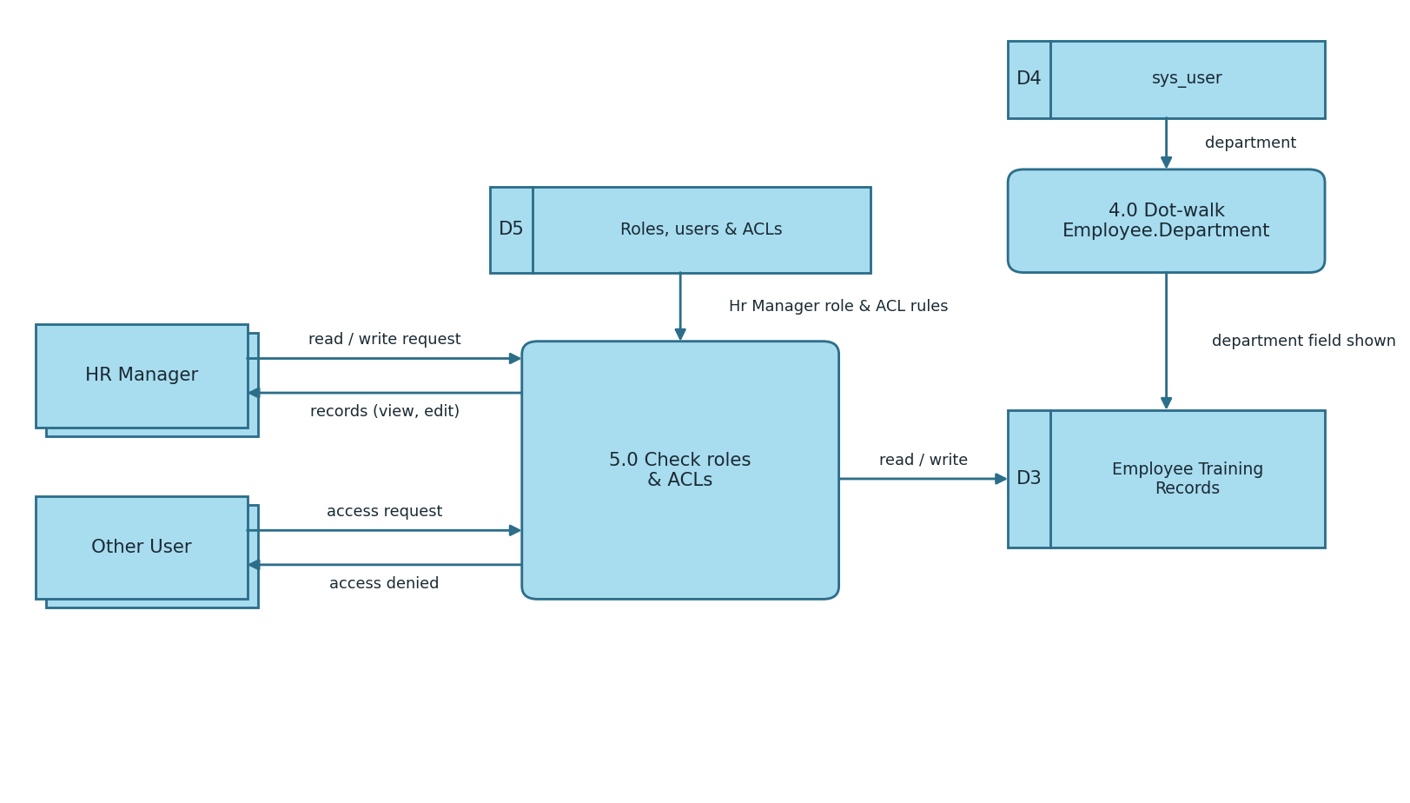
Figure 3: DFD Level 1 (dot-walking and access control)
Flow
- Dot-walking (4.0) reads Department from the linked sys_user record and shows it on the Employee Training Records form and list.
- When a user requests the table, the roles and ACL rules (D5) are checked (5.0).
- A user with the Hr Manager role is granted read and write access; any other user is denied access.

User Stories
User stories for the Import Data Using Transform Maps project, grouped by user type and functional requirement (epic).
User Type | Functional Requirement (Epic) | User Story Number | User Story / Task | Acceptance criteria | Priority | Release
Administrator | Table creation | USN-1 | As an administrator, I can create the Employee Training Records table with the fields Training Name, Completion Date, Status and Employee (reference to sys_user). | Table u_employee_training_records is created with all four columns | High | Sprint-1
 |  | USN-2 | As an administrator, I can add choice values (In Progress, Completed) to the Status field. | Status drop-down shows the configured choices | Medium | Sprint-1
 | Data import | USN-3 | As an administrator, I can prepare an .xlsx file with Training Name, Completion Date, Status and Employee columns. | File has a header row and the records to import | High | Sprint-1
 |  | USN-4 | As an administrator, I can upload the file using Load Data to create the import set table u_employee_training. | Import progress shows State: Complete and Completion code: Success | High | Sprint-1
 | Transform map | USN-5 | As an administrator, I can create a transform map from the import set table to the Employee Training Records table. | Transform map is saved with the correct source and target tables | High | Sprint-1
 |  | USN-6 | As an administrator, I can add field maps for training name, completion date, status and employee. | Field Maps list shows all four fields mapped | High | Sprint-2
 |  | USN-7 | As an administrator, I can run the transform to move staged rows into the target table. | Transformation shows Complete / Success and records appear in the target table | High | Sprint-2
 | Dot-walking | USN-8 | As an administrator, I can dot-walk Employee.Department onto the form layout. | Department field is visible on the form and in the list view | Medium | Sprint-2
 | Roles & users | USN-9 | As an administrator, I can create a user (backup user) and an Hr Manager role, and assign the role to the user. | Roles tab of the user shows Hr Manager as Active | High | Sprint-2
 |  | USN-10 | As an administrator, I can restrict the application menu and module to the Hr Manager role. | Menu and module Roles field lists Hr Manager | Medium | Sprint-2
 | ACL | USN-11 | As an administrator, I can elevate to security_admin and create a read ACL on the table for the Hr Manager role. | ACL (operation: read) exists with Hr Manager under Requires role | High | Sprint-3
 |  | USN-12 | As an administrator, I can create a write ACL on the table for the Hr Manager role. | ACL (operation: write) exists with Hr Manager under Requires role | High | Sprint-3
HR Manager | Record access | USN-13 | As an HR manager, I can open Employee Training Records and view and edit the records. | When impersonated, the list opens and the fields can be edited | High | Sprint-3
 |  | USN-14 | As an HR manager, I can see each employee's department in the record without entering it. | Department is shown from the linked sys_user record | Medium | Sprint-3
Other User | Record access | USN-15 | As a user without the Hr Manager role, I cannot see the Employee Training Records table. | When impersonated, the application is not in the navigator | High | Sprint-3

